Hjulk's letter will have been collected by the child grandparent and Thrumbul will leverage this for a favour from Hjulk.

He will employ Hjulk to kill Dylan Turnfall the owner of Dylan's with a specific dagger, the dagger's blade will be identical to the guard's and spark a revolt in the black borough

This revolt will bolster Thurmbuls position and form a local business council in the sector of the city, Calling Lyndsay out of the race in the Red Cape.

The child is the Palace of Pleasure under a trapdoor in the pantry, there are a total of five guards in the building two of which are in the basement.

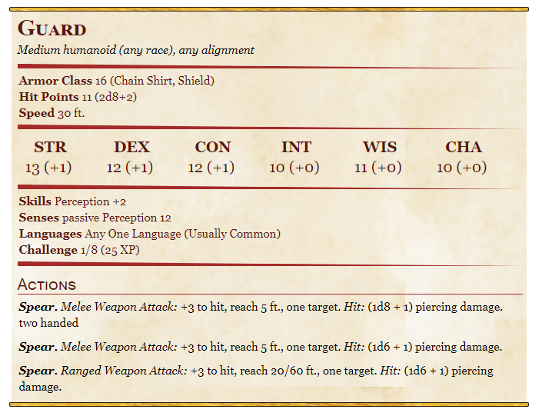

Additionally Garen Merthil will attempt to escape, after the guards have died

Alakant is in the East, where Anya went.